DIKSHA is MHRD’s national digital platform for teachers which offers resources for teaching, learning and professional development.
DIKSHA is a National Digital Infrastructure that States can use for their respective teacher-centric initiatives. Teachers will be able to use DIKSHA to access and create high quality teaching, learning and assessment resources for all subjects and levels in all Indian languages.
DIKSHA aims to strengthen ‘Our Teachers, Our Heroes’
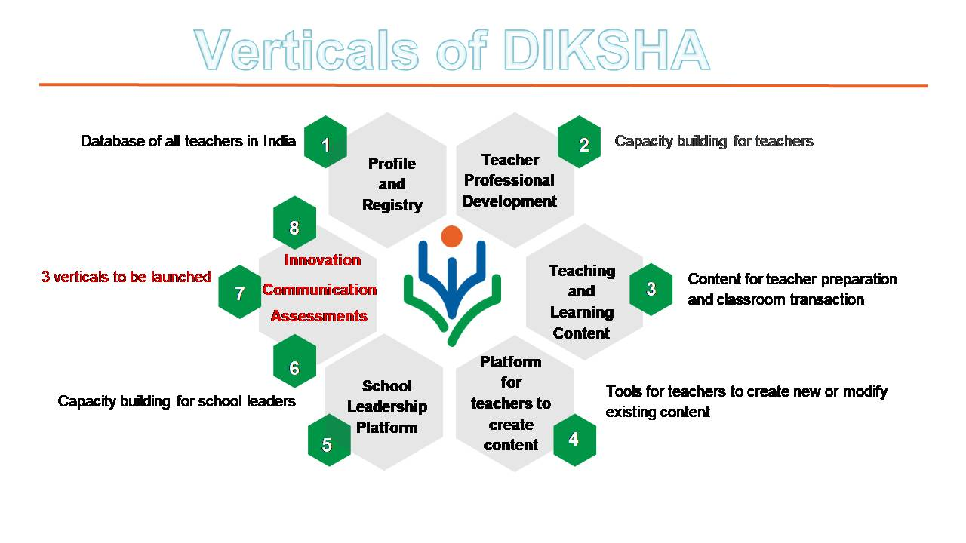
1. Teacher Profile and Registry- Teacher profile will be validated for in-service teachers by converging data from existing databases or collecting data from the field.
2.Teaching and Learning Content (TLC)- TLC consists of curriculum linked resources for teachers and students. Resources will be available in varied formats such as Lesson plan, Audio, videos, PDFs, interactive content etc.
3. Teacher Professional Development (TPD)- TPD will consist of modules for aiding teachers in their professional development and building capacities in newer areas.
4. Platform for Content Creation by Teachers- Using DIKSHA platform, teachers can create relevant content and showcase their content to all users associated with the platform.
5. School Leadership Platform- School leaders will have access to content to improve upon their leadership skills as well as equip themselves to create content. A registry of school leaders will also be created leveraging DIKSHA registry.
6. Assessments- DIKSHA will provide provision for various kinds of assessments including student assessments
7. Communication- Communication on DIKSHA will enable Centre and States to make announcements and issue news, circulars, directions, regulations and other officials notifications to teachers .
8. Innovation- DIKSHA will enable sharing of best practices amongst the teacher community and innovative organizations
Teaching and Learning Content
It includes curriculum linked additional resources for teachers and students which may be in varied formats –
- Audio , Video, Publications , Action Research Reports, Lesson plans , Stories, Game, Self –Learning Material , interactive content, e-Textbook, Website links, News .

(File accepted for uploading content in DIKSHA- pdf, mp4, webm, epub, youtube, h5p and html zip and Max file size - 50 Mb)

Visit the website of DIKSHA to know more- https://diksha.gov.in/
Energized Textbooks (ETB):
Energized textbooks will leverage QR codes to link the created digital content with the existing textbooks. Different resources can also be linked to textbooks via QR codes .
What is Q R Code
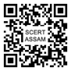
Quick Response (QR) Code is a machine-readable code consisting of an array of black and white squares, typically used for storing web-links or other information for reading by the camera on a smart-phone. QR code is used to log into websites/ weblinks.
Many paid or free mobile apps are available with the ability to scan the codes and which will redirect to an URL. Eg.
- DIKSHA App
- Cam Scanner.

Importance

Textbooks would have to be “energized”, carrying a QR code which would allow the students/teachers to access additional resource material to understand the lesson/chapter.
“Energized Textbooks”, carrying a QR code would allow the students to learn additional language (Hindi, English etc.) as QR Code will be linked to Audio, Video, Text material developed in different languages/mediums.
QR code saves time and effort of the user as user will not have to type a URL manually.
Content residing behind the QR code can be modified or substituted at any time
QR code incorporated textbook will be helpful for engaging students in an indirect way of acquiring knowledge of the lessons of textbooks instead of wasting their valuable time in searching other web links.
Teachers will be able to upgrade themselves to digital teaching methods.
The following Textbooks are Energized with QR Codes in the State of Assam (1st Phase )

Subject | Class | Medium
Social Science | Class VI | (English & Assamese Medium)
Social Science | Class VII | (English & Assamese Medium)
Social Science | Class VIII | (English & Assamese Medium)
Mathematics | Class V | (English & Assamese Medium)
Science | Class-VIII | (English & Assamese Medium)
English | Class V

Detail instructions for scanning of a QR Code is incorporated in the above mentioned textbooks.

